CALENDARS AND DESK DIARIES FOR 2017 - Evocative Cornwall / Kernow Hyrethek

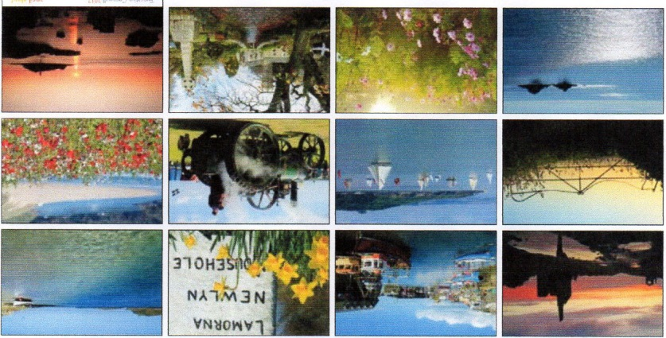

A HIGH QUALITY CORNISH, 13 MONTH, CALENDAR 2017 IS AVAILABLE to Bards with dates of key annual Cornish events, festivals and celebrations PLUS Gorsedh Kernow activities and dates. THIS IS A CORNISH PRODUCTION by Pentyr Publishing with Days and Months in Cornish and English. Price:
£6.99 + £1.00 p&p = £7.99 each to U.K. addresses
£6.99 + £3.70 p&p = £10.69 each to Europe (air mail)
£6.99 + £5.00 p&p = £11.99 each to Rest of World (air mail) : less £2.35 for surface mail, up to 8weeks’ delivery.
Newlyn Artists Calendar
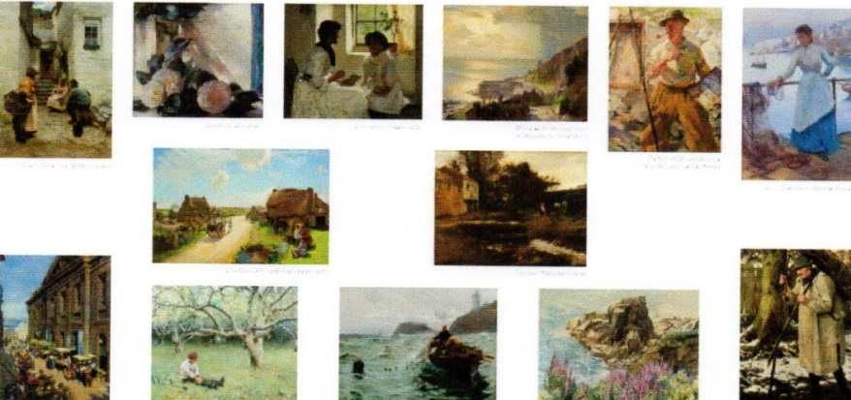

A HIGH QUALITY CORNISH, 13 MONTH, NEWLYN ARTISTS CALENDAR 2017 is available to Bards, also a Cornish production by Pentyr Publishing. Price:
£7.99 + £1.00 p&p = £8.99 each to U.K. addresses
£7.99 + £3.70 p&p = £11.69 each to Europe (air mail)
£7.99 + £5.00 p&p = £12.99 each to Rest of World (air mail) : less £2.35 for surface mail, up to 8weeks’ delivery.

EVOCATIVE CORNWALL ENGAGEMENT DIARY 2017 by Sarah Lay of Pentyr Publishing
one week to each page with a photograph by Sarah Lay – a toal of 52 photographs of Cornish scenes. Price:
£11.00 + £1.00 p&p = £12.00 each to U.K.
£11.00 + £2.40 p&p = £13.40 each to Europe (air mail)
£11.00 + £4.00 p&p = £15.00 each to Rest of World (air mail) : less £2.35 for surface mail, up to 8 weeks’ delivery.
………………………………………………………………………………………………………………………………………

I would like ………..‘Evocative Cornwall’ calendars @ £………. each and/or ……….‘Newlyn Artists’ calendars @ £ …… each

and/or …….. desk diaries @ £………. each £………. TOTAL posted to:

Name…………………………………………. Address……………………………………………….…………………………………………………………………

…………………………………………………… Tel: …………………………………………….. e-mail: ……………………………………………………………
Cheques should be made payable to Gorsedh Kernow. Please return completed form to:

Barbara and Keith Shaw, Clitters House, Clitters, Callington, Kernow/Cornwall, PL17 8HP.

e-mail: keithandbarbarashaw@btinternet.com tel: 01579 370344
Many thanks in anticipation – oll an gwella.

